 | PERSONAL INFORMATION
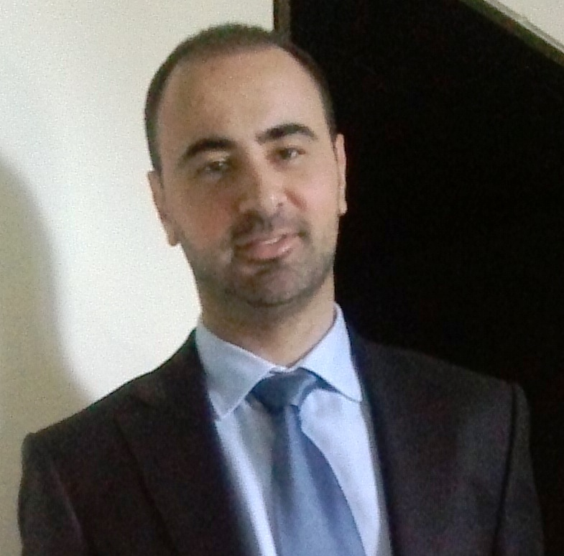 | Name: | Georgios Georgiopoulos, MD
 | Citizenship | Greek
 | Date of Birth: | 17.08.1981
 | Position | Cardiologist-Assistant Professor (tenure track)
 | Institution | University General Hospital Attikon, 2nd Cardiology Department
 | Other active positions | - Research associate, Department of Clinical Therapeutics, National and Kapodistrian University of Athens, Greece  - Lecturer (visiting)  School of Biomedical Engineering and Imaging Sciences,  King’s College London, UK  - Clinical Lecturer (honorary)  Institute of Cardiovascular Science,  University College London, UK  - Lecturer (visiting), Kings College London, School of Biomedical Engineering and Imaging Sciences, St Thomas Hospital, United Kingdom  - Affiliated Researcher, Scuola Superiore Santa Anna, Institute of Life Sciences, Pisa, Italy
 | Address | Rimini Street 1, Athens, 12462, Greece
 | E-mail/Phone: | ggeorgiop@med.uoa.gr  georgiopoulosgeorgios@gmail.com  georgios.georgiopoulos@kcl.ac.uk  +30-6937366315
 | ORCID/Researcher ID | 0000-0001-7661-5253
Registration body |  | Athens Medical Society
Registration ID |  | 072453
PERSONAL STATEMENT(Research Focus)
I am a physician scientist with significant experience in translational research on mechanisms of atherosclerosis, vascular inflammation and vascular senescence. I have expertise in multimodality imaging of the cardiovascular system at different levels (micro-, macro-circulation, tissue level and myocardial mechanics). I am also a data scientist with proficiency in cardiovascular epidemiology and advanced statistics (including machine-learning approaches) focusing on risk stratification in cardiovascular diseases as well as on the translational value of basic science mechanisms.

DEGREES
2014 | PhD in Medicine
2013 | MSc in Biostatistics
2009 | MSc in Molecular Medicine
2006 | Medical studies, Medical School Diploma (Grade: Excellent (With Honors)

EDUCATION
01/09/2025 | CP (E6 R3) certificate
02/2024  02/2024  05/2022 | European Association of Cardiovascular Imaging (EACVI): Recertification in trans-thoracic echocardiography accreditation  United States Medical Licensing Examination: ECFMG Certification United States Medical Licensing Examination: ECFMG Certification,Step 1 Basic Science and Step 2 Clinical Knowledge  European Association of Cardiovascular Imaging, EΑCVI: Trans-esophageal ultrasound accreditation
9/2019-9/2021 | European Heart Academy and London School of Economics, Executive MSc in Health Economics, Outcomes and Management in Cardiovascular Sciences, London School of Economics, UK
9/2021 | European Resuscitation Council: Accreditation in Advanced Life Support
9/2021 | European Association of Cardiovascular Imaging, EΑCVI: Level III accreditation in Cardiac magnetic resonance imaging (MRI)
5/2021 | SCCT, Level II accreditation in Cardiac Computed Tomography (Society of Cardiac CT)
10/2018-2/2021 | Postgraduate course in heart failure, British Cardiovascular Society and British Society for Heart Failure, Royal Brompton and Harefield, London
5/2018 | Accreditation in Heart Failure, European Heart Failure Association (HFA)
12/2017 | European Association of Cardiovascular Imaging, EΑCVI: Trans-thoracic ultrasound accreditation Level II
6/2017 | European Society of Cardiology (ESC) and UEMS Cardiac section: European Examination in General Cardiology (EEGC)
5/2017 | United States Medical Licensing Examination: Step 1 Basic Science &Step 2 Clinical Knowledge
6/2011– 10/2017 | Training in Cardiology, 1st Department of Cardiology, National and Kapodistrian University of Athens, Greece, Hippocration Hospital  Board certified in Cardiology:10/2017

ACADEMIC CAREER
 | 01/07/2025-today |  | Cardiology / Assistant Professor on tenure track, Department of Medicine, National and Kapodistrian University of Athens.
 | 1/3/2024-30/06/2025 |  | Assistant Professor on tenure track with the subject of Physiology, Department of Medicine, University of Patras.
 | 10/2021-6/2023 |  | Fixed-term academic researcher, Department of Clinical Therapeutics, National and Kapodistrian University of Athens, Greece
 | 9/2021-9/2024 |  | Lecturer (vis.), School of Biomedical Engineering and Imaging Sciences, King’s College London, United Kingdom
 | 6/2022-6/2024 |  | Clinical Lecturer (hon.), Institute of Cardiovascular Science, University College London (UCL), United Kingdom
 | 10/2021-10/2024 |  | Affiliated Researcher, Institute of Life Sciences, Scuola Superiore Santa Anna, Pisa, Italy
 | 4/2021-4/2024 |  | Associate Clinical Researcher, Faculty of Medical Sciences, Newcastle University, UK
 | 5/2021-9/2021 |  | Fellow of the European Association of Cardiovascular Imaging (FEACVI),  Toscana Gabriele Monasterio Foundation, University of Pisa
 | 9/2019 – 5/2021 |  | Clinical Research fellow, School of Biomedical Engineering and Imaging Sciences, St Thomas Hospital, King’s College London, United Kingdom
 | 04/2019-03/2020 |  | Fellow of the European Association of Cardiovascular Imaging, School of Biomedical Engineering and Imaging Sciences, Kings College London, St Thomas Hospital, UK
 | 12/2018-9/2020 |  | Young fellows of the European Atherosclerosis Society 2019-2020
 | 01/2015-10/2020 |  | Research Fellow, Institute of Cardiovascular Regeneration, Centre of Molecular Medicine and Department of Cardiology, Goethe University Frankfurt, Germany
 | 04/2019-9/2019 |  | Research Fellow of the European Association of Cardiovascular Imaging, School of Biomedical Engineering and Imaging Sciences, Kings College London, St Thomas Hospital, UK
 | 12/2018-04/2019 |  | Fellow in Advanced Cardiac Imaging, Hellenic Society of Cardiology, King’s College London
 | 10/2017-01/2019 |  | Post-doctoral researcher; funded by State Scholarships of Greece (IKY) and European Union. Department of Clinical Therapeutics, National and Kapodistrian University of Athens
 | 10/2017-8/2018 |  | Cardiologist (consultant level), 1st Department of Cardiology, National  and Kapodistrian University of Athens, Greece, Hippocration Hospital
 | 6/2011-10/2017 |  | Fellow in Cardiology, 1st Department of Cardiology, National and Kapodistrian University of Athens, Greece, Hippocration Hospital
FUNDING (a total of 750.000 €)
2023-2025 | Raising awareness for TTR amyloidosis, International Society of Amyloidosis-Mayo Clinic and Pfizer (123.360 €)
4.2021-10.2021 | Multi-modality imaging for the early diagnosis of cardiac amyloidosis, European Association of Cardiovascular Imaging (15.000€)
09.2021-09.2023 | HYPER-MASTIC project: anti-hypertensive role of mastic , European Union-Greek Ministry οf Development and Investments (144.000€)
10.2020-4.20202 | Early diagnosis of diabetic cardiomyopathy by comprehensive MR imaging, EFSD/Sanofi European Diabetes Research Programme (100.00€)
10.2019-10.2021 | Early diagnosis of hypertension mediated heart disease, Onassis  Foundation (20.000€)
04/2019-03/2020 | Coronary microvascular dysfunction in heart failure with preserved and mid-range ejection fraction , European Association of Cardiovascular Imaging (25.000€)
04.2017-04.2019 | Clinical value of peripheral blood mononuclear cell noncoding RNAs as determinants for human atherosclerosis, European Union (EU) (29.000€)
10/2019-ongoing | Heart-to-brain Connection in Alzheimer’s Disease, King’s College London (125.470€)
11/2019-ongoing | GlycA as a novel biomarker linking bacterial-mediated inflammation to adverse cardiometabolic traits in the young, British Heart Foundation (168,940€)

AWARDS AND HONORS
2023 | Young Investigator Award Koronare Herzekrankungen, German Society for Cardiology
2022 | 1st Award, Hellenic Association of Cardiology
2021 | 1st Award, Hellenic Association of Cardiology
2019 | European Heart Academy&European Society of Cardiology: Scholarship for training in Health Economics
2019 | Hellenic Association of Cardiology: Scholarship for advanced cardiovascular imaging
2018 | 2nd Award, Hellenic Association of Cardiology
2017 | 1st Award, Hellenic Association of Cardiology
2016 | 2nd Award, Hellenic Association of Cardiology
2015 | 1st Award, Hellenic Association of Cardiology
2015 | 2nd abstract award, German Cardiac Society
2014 | Ph.D with Honors
2014 | 1st abstract award, Hellenic Society of Rheumatology
2008-2014 | Scholarship for Ph.D research, John Latsis Foundation, Athens
2009 | Scholarship from the Committee for Research, University of Athens
2007-2009 | Scholarship for MSc research, Onassis Foundation, Athens
2006 | Medical Degree with Honors

INVITED SCIENTIFIC TALKS >50

BIBLIOGRAPHY
Publication metrics (as of 01.01.2026)
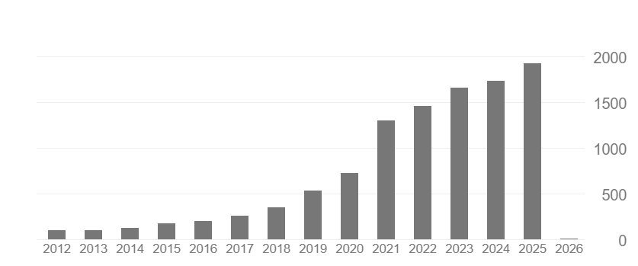
• Total publications (PubMed) : 301
• Citations (Google Scholar) : 11056
• H-index (Google Scholar) : 53
• i10-index: 216

https://scholar.google.gr/citations?user=wkiCH6IAAAAJ&hl=en
https://pubmed.ncbi.nlm.nih.gov/?term=georgiopoulos+g&sort=date

